NAME: J.K.RISHIK
REG. NO : 192511052

TASK 01-

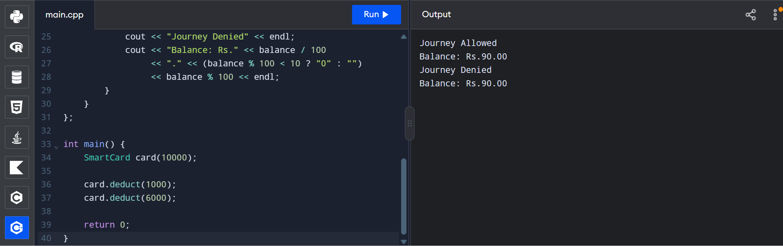

TASK 02

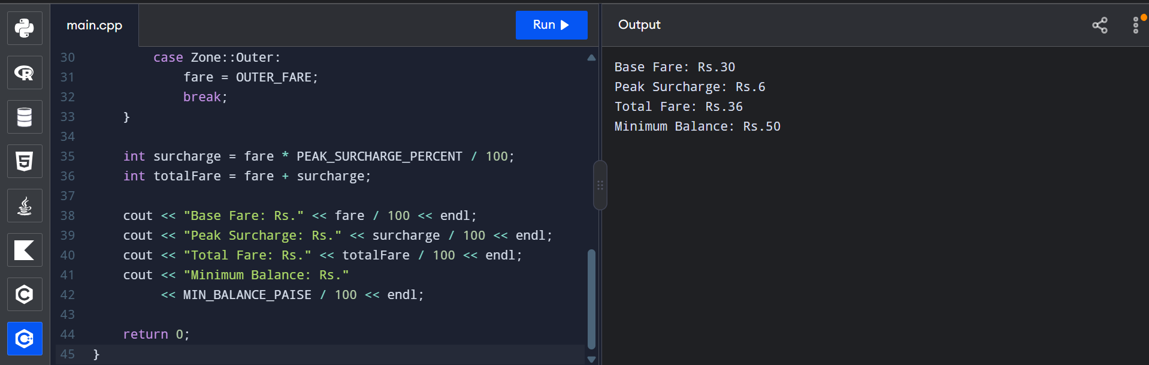

TASK 03

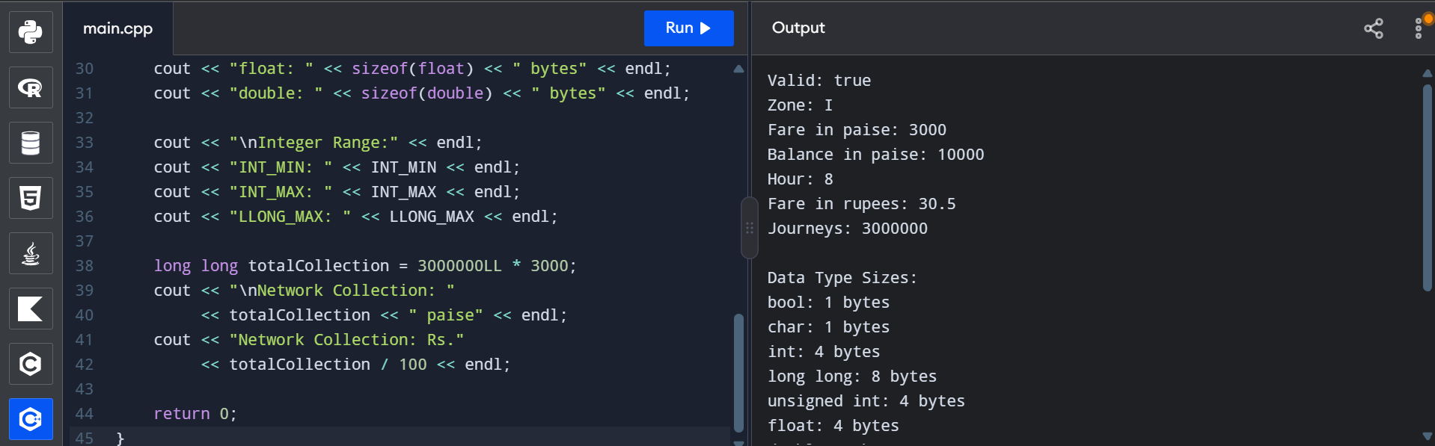

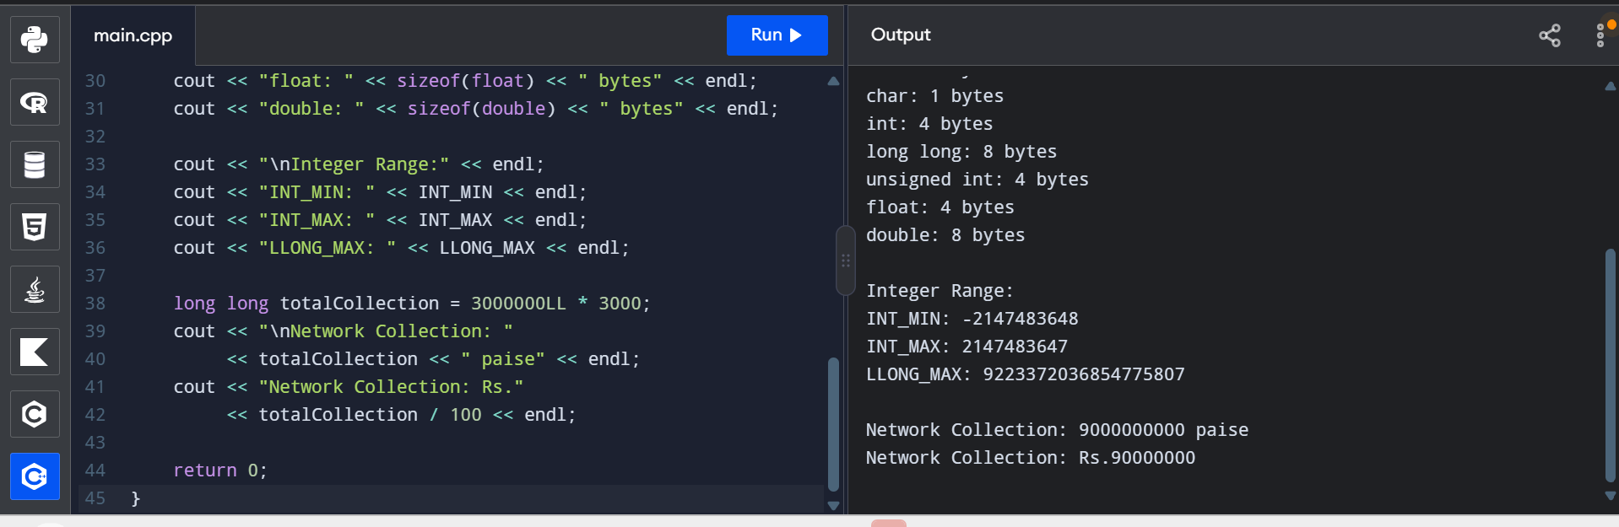

TASK 04

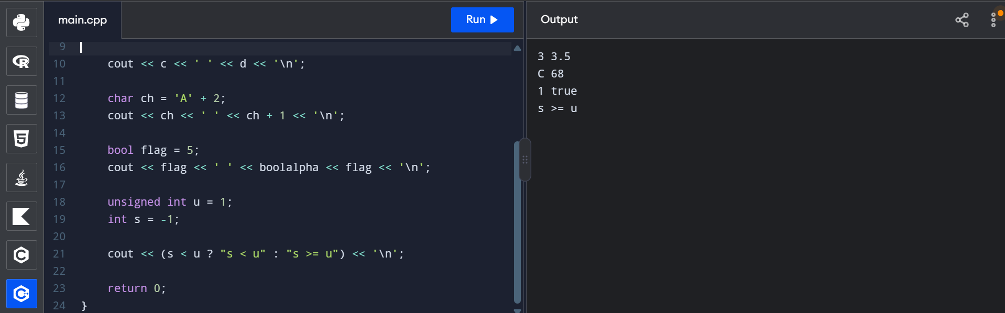

TASK 05

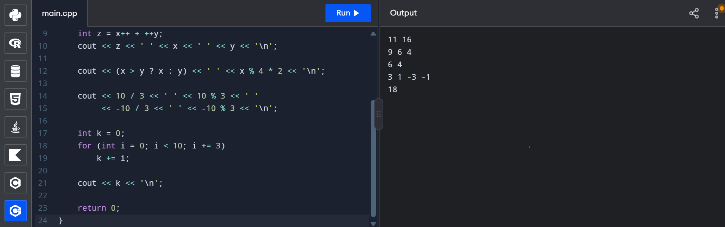

TASK 06

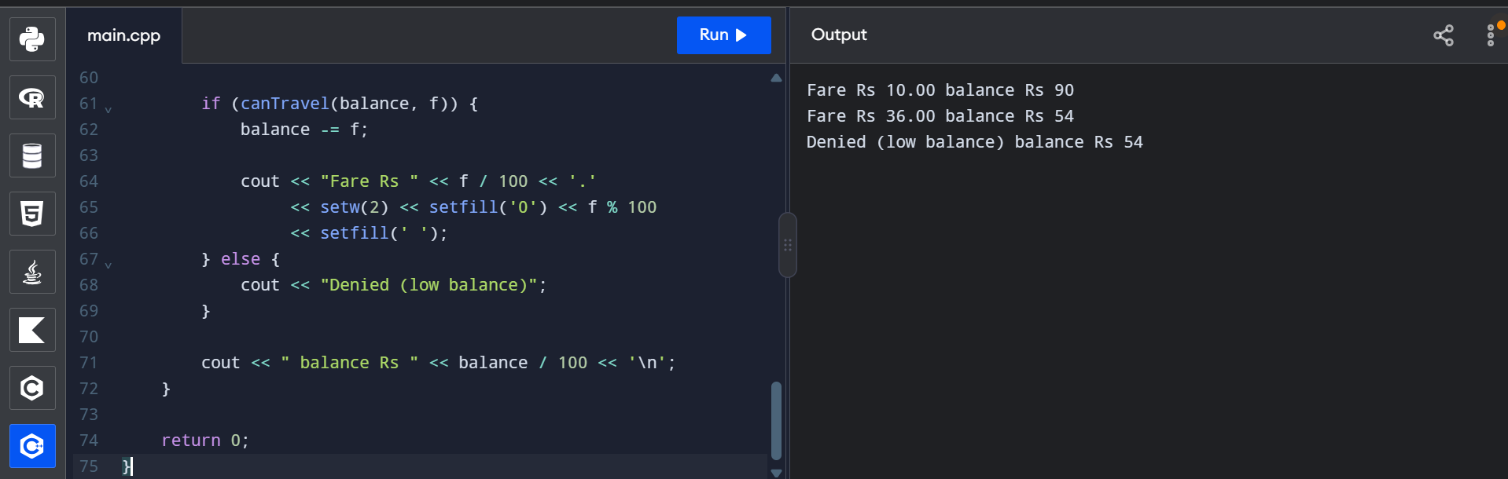

TASK 07

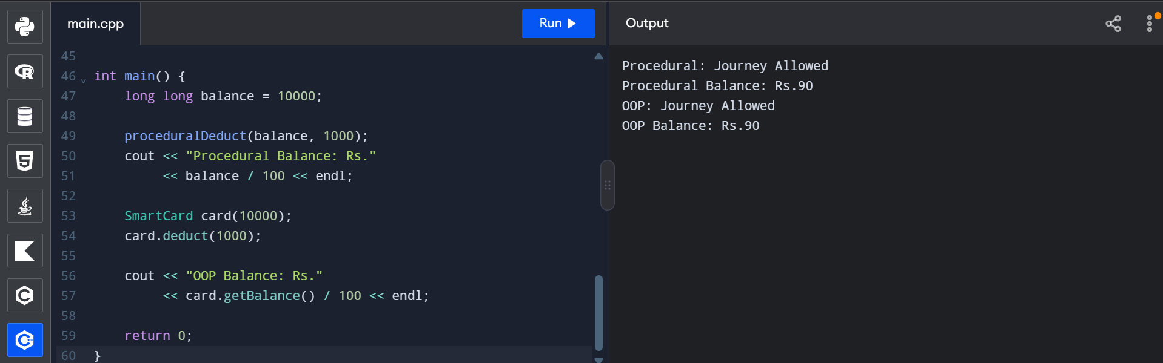

TASK 08

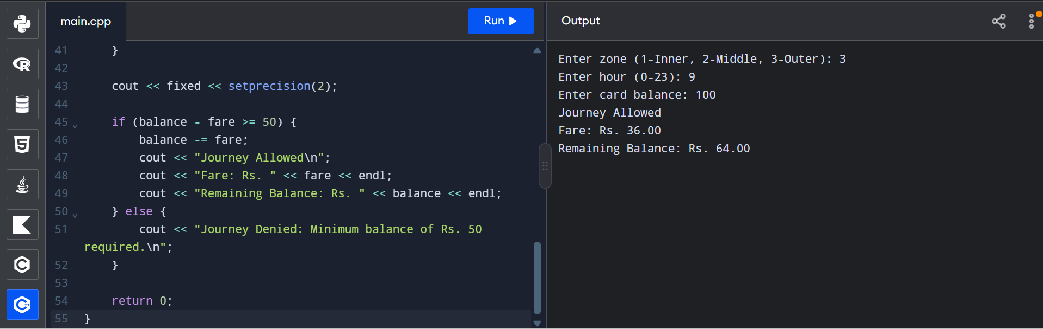

TASK 09

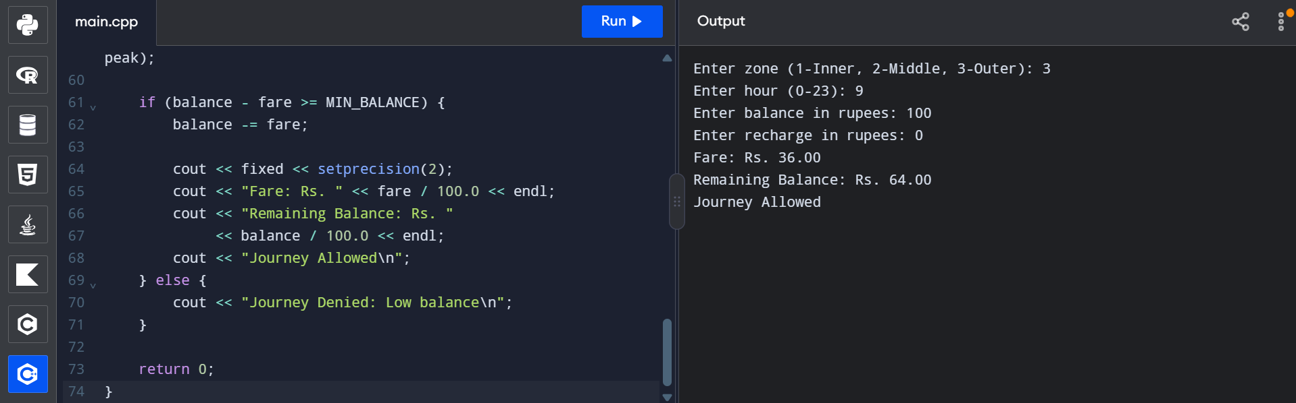

TASK 10
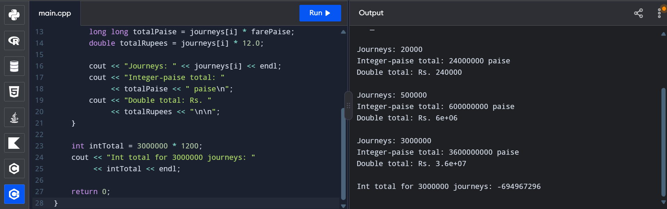

TASK 11

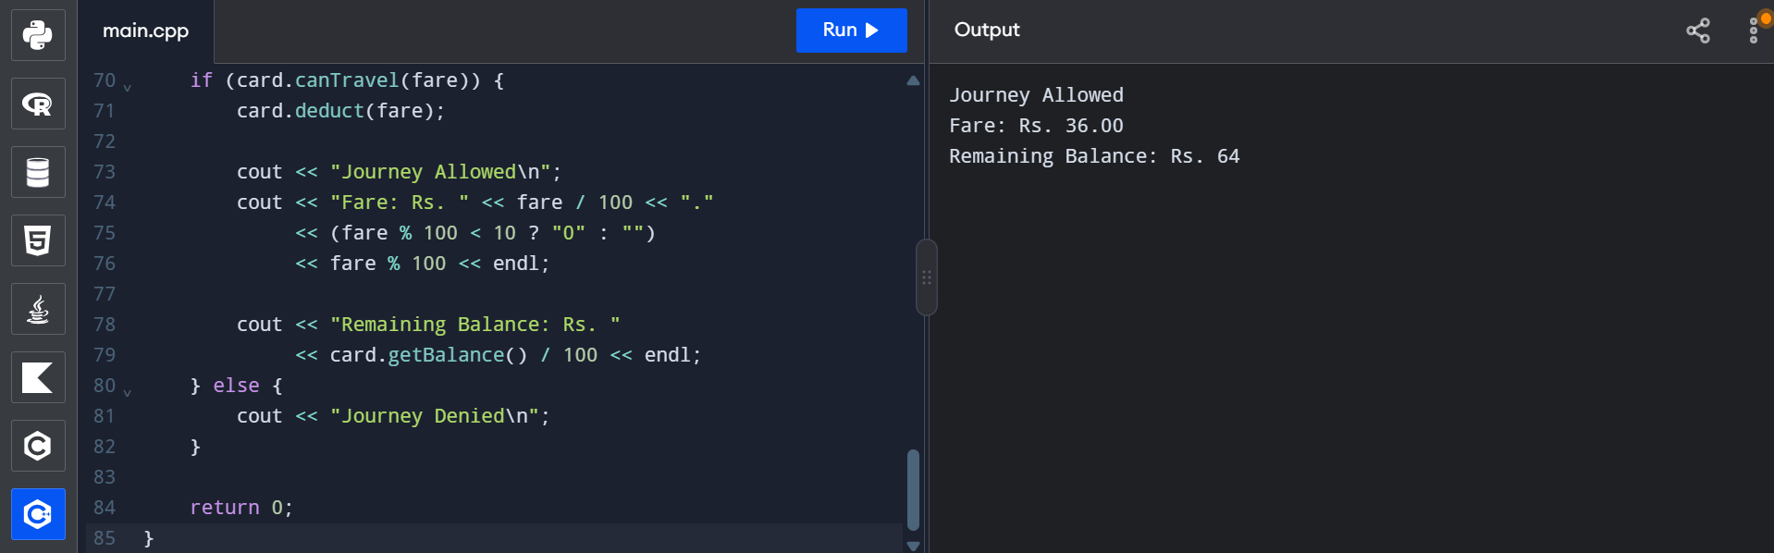

TASK 12

